**Project-1: Temperature and Gas Detection System Using Arduino**

I designed this project in such a way that, when a user wants the temperature reading the system works on it or when the user wants to test for the presence of smoke. The system displays the readings on an LCD screen and allows the user to switch between temperature and gas readings using two push buttons.

**Components Used:**

1. **Arduino UNO**.
2. **Temperature Sensor-LM35**
3. **Gas Sensor-MQ-2**
4. **LCD Display (16x2, I2C Interface)**
5. **Push Buttons (x2)**
6. **Resistors**

**Working Principle and Functionality :-**

When the button 1 is pressed the gas sensor is activated, which sends analog readings to the Arduino. The Arduino checks whether the values are greater than the predefined threshold value (in my code it is 150). As per the satisfaction of the condition, the Arduino commands the LCD to display messages.

When the button 2 is pressed the temperature sensor is activated. This sensor sends analog signals to the Arduino, which interprets these signals and converts the analog values into voltage which is further converted into temperature in Celsius. The temperature is displayed on the LCD as per the code.

If no buttons are pressed the system asks the user to press any of the one by displaying the message “Press 1 or 2”.

**Code Implementation:**

* The Arduino reads input from the sensors and buttons.
* Debounce logic (delay 200) ensures buttons function properly even without accidental triggers.
* The LCD is updated based on button presses to show either temperature or smoke detection.

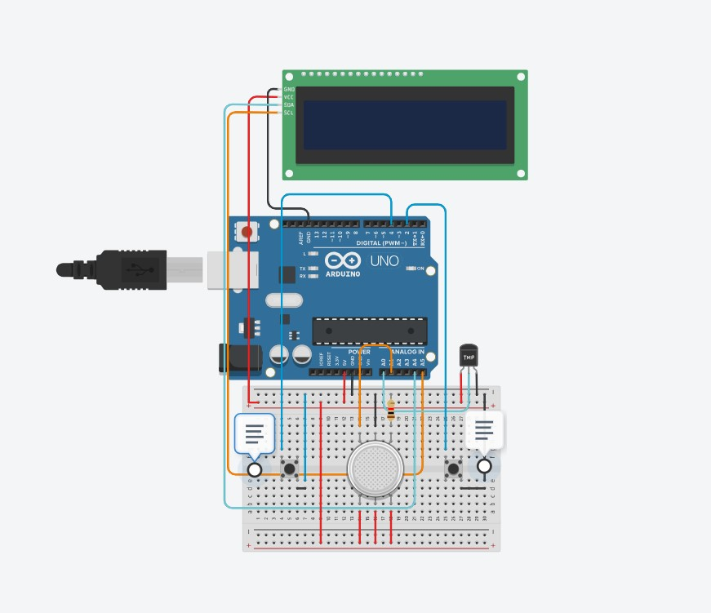

**Conclusion :-**

This project provides a basic yet effective method for monitoring temperature and detecting harmful gases. It is useful for home safety applications, laboratories, and industries where air quality monitoring is essential. Further improvements(Can’t be made in Tinkercad due to unavailability of some resources) can be made to enhance its usability and features.